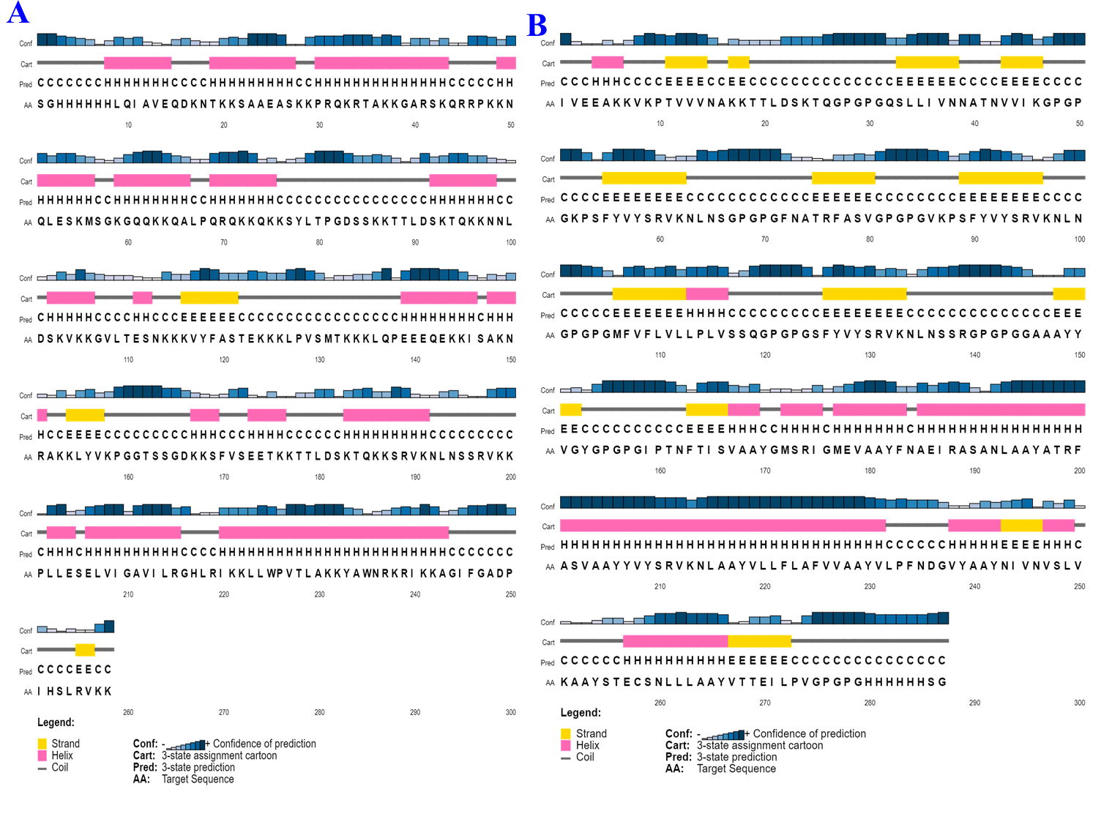

**Fig. 1S** shows predicted protein secondary structure of Poly1 (A) and Poly2 (B). The protein sequence is at the top, with single-letter amino acid residue codes. Below the sequence are blue and red alpha helices and beta sheets, the expected secondary structure elements. Taller bars indicate higher prediction confidence.

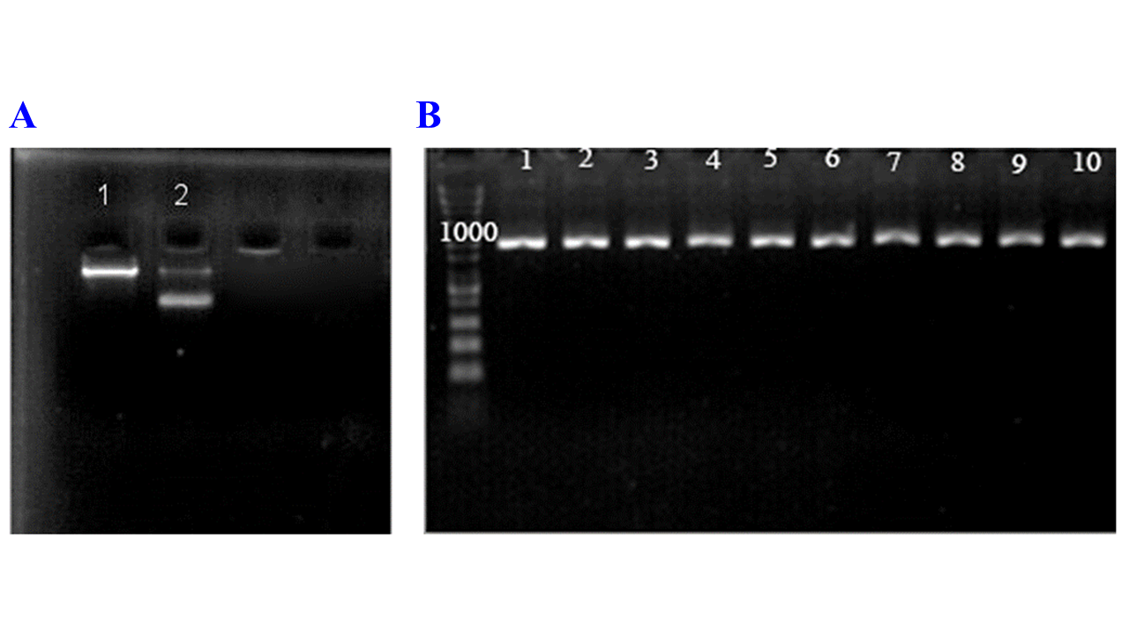**Fig. 2S**. The pHEN4 plasmids. (A)1- undigested pHEN4 2- digested with SalI and XbaI lane 2. (B) Analyzing the of Poly 1 and Poly 2 fragment replication outcomes. Lanes 1–5 are poly 1 band, and lanes 6–10 are poly 2 band.

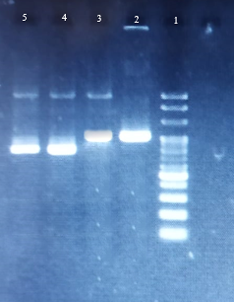

**Fig. 3S.** Enzymatic digestion of the Poly 1 and Poly 2 fragment PCR products. Lane 1: Biofact company 1kb ladder, Lane 2: undigested sample of Poly 1 fragment, lane 3: undigested sample of Poly 2 fragment, lane 4: digest result of Poly 1 fragment with *Sal*I and *Xba*I, lane 5: digest result of Poly 2 fragment with *Sal*I and *Xba*I

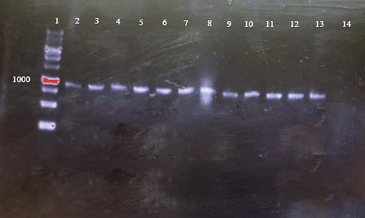

**Fig. 4S.** Analysis of positive clones using colony PCR. Lane 1: Biofact Company 1kb Ladder, lanes 2–8: colonies containing pHEN4–Poly2 recombinant phagemid vector, lanes 9–13: colonies containing pHEN4–Poly1 recombinant phagemid vector, and lane 14: negative control.

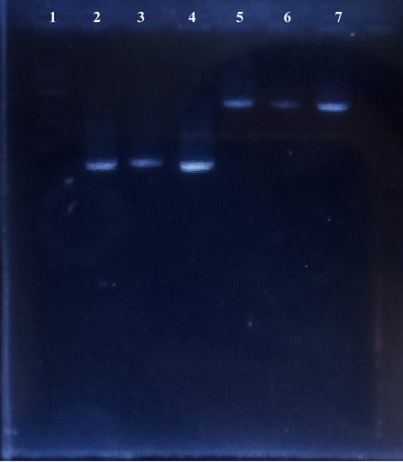

**Fig. 5S**. Colony PCR was performed on grown colonies to confirm the presence of two plasmids. Lane 1: Fermentas company 1kb ladder, lanes 2 and 3: related to pHEN-Poly2, lane 4: related to pHEN-Poly1, and lanes 5, 6, and 7: related to the plasmid pM13delpIII.